ECOS 2022: Manuscript Template
First Authorª, Second Author^{b}, Third Author^{c} and Fourth Author^{d}
ª Institution, City, Country, e-mail
^{b} Institution, City, Country, e-mail,
^{c} Institution, City, Country, e-mail, CA
^{d} Institution, City, Country, e-mail
Abstract:
Manuscript submitted to ECOS Conference must describe original, previously unpublished work (in a journal or a conference with refereed proceedings), and must not be simultaneously submitted or be under review for publication elsewhere. Authors are kindly requested to prepare the manuscript using this template. If needed, detailed information on paper preparation can be found in Section 2.
Keywords:
Thermodynamics; Energy; ECOS Conference; Exergy; Sustainability.
1. Introduction
Papers that already appeared in unpublished or informally published workshop proceedings may also be submitted (in this case please cite the prior publication in the list of references). For information on Ethics in Publishing and Ethical guidelines for journal publication, see: <http://www.elsevier.com/publishingethics> and <http://www.elsevier.com/ethicalguidelines>.
1.1. Platform submission
Authors are requested to submit their manuscripts ONLY via the DIS Eventure platform accessible from the Conference page http://ecos2022.org/. Registration of the Corresponding Author is needed to perform any upload. This registration is an Author Registration and does neither imply any obligation on the part of the Author, nor generate any charge. Conference Registration and the corresponding payment options can be finalized later through a different window, according to the schedule published on the site.
1.2. Information
Any doubts regarding the submission process should be sent to the local organization committee contact, through the e-mail: hdy@discongress.com.
2. General information about ECOS 2022 papers
2.1. Manuscript preparation process
The manuscript must be prepared in English (British or American spelling) and should be free of grammatical, spelling and/or punctuation errors. The manuscript must be thoroughly edited and proofread before it is submitted. Authors have the responsibility to ensure clear and adequate English expression, since indecipherable language could be a valid reason for rejection of the paper.
Units in the paper must be according to the International System of Units (SI). Other units may be given in parentheses (when they first appear in the text), dual-unit tables, or an appendix.
Authors are requested to prepare the manuscript by using this template. The manuscript length is limited to a mandatory maximum of twelve (12) pages.
The template documents contain necessary information regarding desktop publishing format, type sizes, and typefaces. Formatting styles are classified in three groups:
- Character styles, indicated by prefix CS.
- List styles, indicated by prefix LS.
- Paragraph styles, indicated by prefix PS, (only Normal style and Title style do not have that prefix, but they still belong to this group).
2.2. Manuscript submission and review process
Authors are requested to submit their manuscript, without page numbers, as a Portable Document Format (PDF) file, with highest portability and quality options.
For each submission that falls within the scope of the ECOS Conference, at least two independent experts in the field of the submission will be selected to act as reviewers. ECOS Conferences use a single-blind peer review process where the identity of the reviewers will remain anonymous but those of the Authors are public. The appropriate editor will assess the recommendation report from the reviewers as to whether the article should be accepted, revised or rejected. The submitted manuscript, subject to final acceptance on the basis of the Reviewers’ report, will be included in the Conference Proceeding without any modifications.
3. Organization of paper
The basic parts of a paper are listed below in the order in which they should appear:
- Title (Section 3.1.);
- Author(s), author’s (or authors’) affiliation(s), Corresponding author identifier (Section 3.2.);
- Abstract and Keywords (Section 3.3.);
- Subject matter of the paper with numbered main headings and sub-headings (Section 3.4.)
- Acknowledgments, if any, (Section Acknowledgments);
- Appendices, if any, (Section Appendix A, Appendix B);
- Nomenclature with SI units, if any, (Section Nomenclature);
- References (Section References);
3.1. Title
The article title appears centred at the top of the first page. To format the title authors should use the “Title” style from the formatting menu. Only the first word and proper nouns for the title should be capitalized. The use of acronyms and abbreviations in the title should be avoided, unless they are widely understood, or they are accompanied by the expanded expression.
3.2. Authors information
The list of authors follows just below the title. To avoid confusion, the family name must be written as the last part of each author name (e.g. Nikola Tesla, not Tesla Nikola; Ben Roethlisberger, not Roethlisberger Ben; Ming Yao, not Yao Ming). To format the author name(s) use the “PS Authors” style from the formatting menu.
Author details must not show any professional title (e.g. Managing Director), any academic title (e.g. Dr.) or any membership of any professional organization (e.g. Senior Member IEA). Each affiliation must include, at the very least, the name of the institution, city, country and e-mail addresses. For multiple affiliations, each affiliation should appear on a separate line. Author names and affiliations are linked with superscripts. Proper style is the “PS Affiliation” style. Corresponding author identifier (CA) should be put after the e-mail address of the corresponding author selected only. This information is compulsory for the submission process.
3.3. Abstract and keywords
The abstract and keywords follow the title and author information. The headings, Abstract and Keywords, are formatted by “PS Heading A&K” style and do not have a section numbers. The Abstract section should consist of a single paragraph containing no more than 300 words, and should be formatted by “PS A&K” style. Abbreviations and acronyms should be expanded when they appear for the first time in the abstract. Keywords (“PS A&K” style) are usually composed of about five terms or phrases in alphabetical order. The first letter of each keyword or keyword phrase should be capitalized; the keywords or phrases should be separated from one another by semi-colons, with a period (full stop) following the last one.
3.4. Subject matter of the paper with numbered main headings and sub-headings
The subject matter (body) of the paper should be composed of main sections, each preceded by a main heading (“PS Heading 1” style), and sub-sections, each preceded by a subheading (first level “PS Heading 2”, second level “PS Heading 3”, third level “PS Heading 4” style). Numbered Headings (in Arabic numerals) consist of:
- Section number followed by a period.
- Sub-section number within that section, followed by a period.
- One space.
- Text of the heading.
Only the first word and proper nouns for the text of the heading should be capitalized. Main headings of sections Nomenclature, References, Acknowledgments and Appendix are unnumbered.
Paragraphs that follow the headings should not be indented. For body text of the paper proper style is “Normal” style. During the text preparation authors may:
- Manually format any special text that needs to be italicized, bolded, subscripts or superscripts. For emphasis the boldface should be used, while underlining is not recommended in the manuscript. The use of different fonts (usually symbol font) for special purpose should be avoided; instead authors should use the symbols from the Symbol dialog box (Command Insert | Symbol).
- Authors should use the manual hyphenation command to have uniform spacing between the words. Automatic hyphenation should not be used.
- Authors should place an extra line spacing by the Enter key, only after the last paragraph in the page (to start a new Heading, Table or Figure on the next page), or after a table which does not contain the Table footnote. Proper style of extra line is “Normal” style.
Abbreviations and acronyms should be expanded when they appear for the first time in the text, even if they have already been defined in the title or abstract. Abbreviations that incorporate periods should not have spaces: write “C.N.R.S.,” not “C. N. R. S.” Chemical compounds should be named according to the rules of the IUPAC or Chemical Abstracts.
Footnotes should be kept to a minimum and used only for substantial observations. In this case authors should use Microsoft Word’s standard footnote format, and number the footnote by the auto-numbering feature. Proper style of footnote text is “PS Footnote text” style. Endnotes should not be used at all.
3.4.1. The use of landscape format space
In the case that some object (figure or table) is not legible enough – or is exceptionally big – to be contained in the proposed page format, authors may place the object in the following landscape page (see Table B.1 in Appendix B).
To present the object in landscape format space, Word users should follow the next steps:
- Insert a section break (for Word 2003 users: Insert | Break and chose Next page from Break dialog box; Word 2007/10 users Page Layout │ Break │Next page).
- Change the format of page from Portrait to Landscape.
- Create or import the object followed by appropriate number or caption.
- Again insert a new section break (repeat first step).
- Change the format of page from Landscape to Portrait.
Authors are strongly advised to spare the use of landscape pages. In the case it is inevitable, the pages which have landscape format spaces, after printing by PDF printer for Word, should be rotated-clockwise 90 degrees.
3.4.2. Displayed list: Bulleted list and number list
A displayed list is a list that is set off from the text, as opposed to a run-in list that is incorporated into the text. There is no strict rule when to create a displayed list, but within the text lists should not have more than three items. For example, within the text lists would appear: 1) using a number, 2) followed by a closing parenthesis.
For a bulleted list (“LS Bullet List Level 1” style):
- Use a colon to introduce the list.
- The template uses standard bullets instead of checks, arrows, etc. for bulleted lists.
- Tab space between symbol and text is 0.5 cm
For a numbered list (the “LS Number List” style):
- Use a colon to introduce the list.
- Labels should not be numbers enclosed in parentheses because such labels cannot be distinguished from equation numbers.
- Tab space between symbol and text is 0.5 cm.
The ECOS Template also contains list styles: for second level bulleted list (“LS Bullet List Level 2” style), for nomenclature (the “LS Nomenclature” style) and for references (the “LS Reference” style).
3.4.3. Equations and expressions
Important equations appear on their own line, and should preferably be entered using the Equation Editor (EE) software by the following steps:
- Insert the Equation Object, create the equation, and leave the EE.
- Insert comma if equation is considered to be part of a sentence, or period if equation ends the sentence.
- Apply the “PS Equation” style.
- Insert “tab” after punctuation mark.
- Number equations consecutively (1, 2,..) with Arabic numbers in parentheses, as in (1).
, (1)
The recommended order of closures for parenthesis, brackets and braces, is the following:
(2)
Authors should refer to equations in the text by Eq. (1) except at the beginning of a sentence, and by Equation (1) at the beginning of a sentence. If there are chemical formulae included, i.e. reactions, please number them (R1), (R2), etc. Complicated chemical structures should ideally be prepared with chemistry drawing software (e.g. ChemDraw, Chem Windows, ISIS/Draw) and treated like figures.
Expressions which are simple, short, and not of major importance can be left in the text, and written in one-line form (e.g., use β = a/b for fractions). For expressions within a line of text authors should use regular text and the symbols from Symbol dialog box like:
- For binary operations:
- Plus sign (+).
- Minus sign (−), do not use hyphen (-).
- Multiplication sign: dot (·) or cross (×).
- Fractional sign: slash (/) or division sign (÷).
- Composition sign (°), also degree sign.
- For binary relations =, ≠, <, >, and |.
Authors should try to build the complex expressions in EE every time when it is possible. Detailed Lettering format in Word’s EE is not included in the ECOS template, but authors are advised to use the “Arial” and “Symbol” fonts which full size should be set to 12 points. Symbols in equations and expressions must be defined in the Nomenclature, or in some cases immediately following them.
3.4.4. Figures and Tables
Figures and tables are most effective when they are clear, self-explanatory, accurate, easily understood and remembered. In general, tables and figures should have enough explanation in their captions to stand alone.
Tables and figures (graphs, charts, drawing, and photographs) must be embedded in the document. They should be placed between paragraphs, after (or near) their first mention in the text. It is recommended to make separate file for tables and figures because their placement will probably be rearranged after applying all the text formatting.
Figure captions have to be placed below the figures and not in “text boxes” linked to the figures. Table titles have to be placed above the tables. Authors should include a minimum of one sentence summarizing what the figure/table shows or illustrates in the text; also verify that the figures and tables mentioned in the text actually exist.
3.4.4.1. Figures
The recommended font in artwork is Arial, same size as the text. Figure lettering should be large enough to be readily legible when the drawing is reduced. Axis titles on graphs must be labelled with words rather than symbols. As an example, the vertical axis in Figure 1 is labelled as the quantity “Pressure” or “Pressure, p1” not just “p” or “p1”. Units should be put in parentheses.
If figure has a two (or more) parts, authors should include the labels “(a)”,“(b)”… as part of the artwork. Figures are going to be reproduced in colour in the electronic versions of the Proceedings, but in the journals they will be printed in black and white. Therefore, distinctions have to be used so that images can still be understandable in black and white printings.
For easier manuscript preparation authors are advised to create separate figure files and convert them into proper file format. For ECOS proceedings TIF, JPG, GIF, and PNG (raster artwork) and EPS, PDF and EMF (vector artwork) are the preferred formats; Word, Excel and PowerPoint format are also acceptable. It is important to understand that the non-preferred formats are not ideally suited to high-quality image reproduction, and are not acceptable for conversion to a paper that may be considered for archival journal publication.
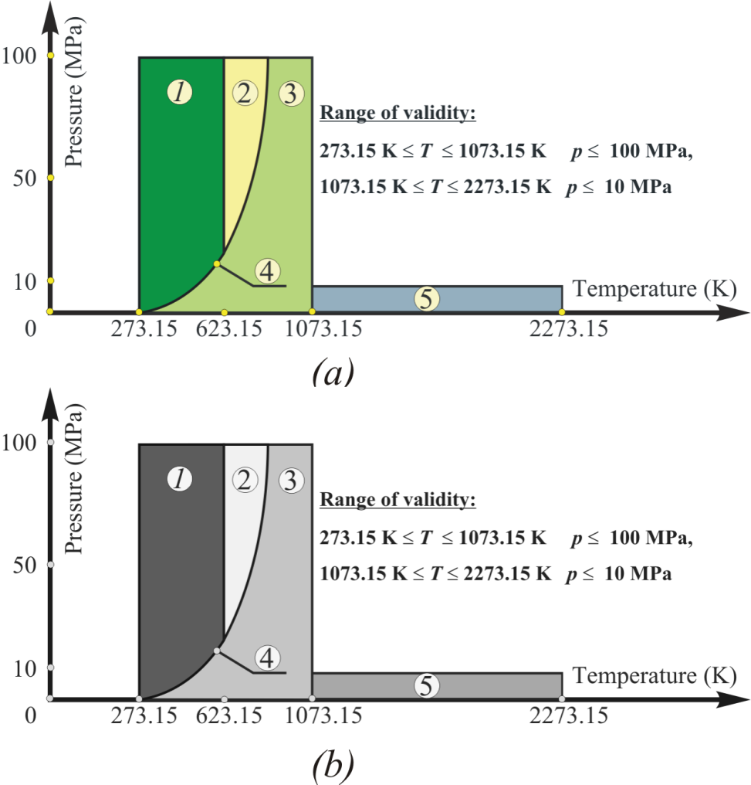
Figure. 1. Use of appropriately contrasting colours for black and white printing: a) colour figure, b) greyscale figure.
Before being inserted in the document each figure should be:
- Prepared as simply as possible for clarity. Avoid sideways illustrations if at all possible.
- Closely cropped, to minimize the amount of white space surrounding the illustration.
- Resized to the desired final dimensions in order to minimize the final document file size.
- Prepared with at least 300 dpi resolutions for raster artwork (greyscale and colour halftones), 600 dpi for combinations (line art and halftone together) and 1200 dpi for line art.
To embed (insert) images, prepared in separate files, authors should use (Insert | Picture | from File) operation. If artwork is created by MS Office application (Word drawing, Excel graph, PowerPoint illustration), recommended operation, Copy | PasteSpecial | Picture (Enhanced Metafile), saves file memory and copy only a static picture. Authors should not use Paste link option.
If the authors are providing scanned figures, they have to be clear, with all the legends and data labels easily readable. If this is not possible, the author must redraw the figures especially in the case of simple ones. Illustrations borrowed or adapted from another source have to be properly acknowledged.
For the figure layout use the “PS Figure Place” style. Figure caption (“PS Figure Caption” style) should be below the figure. The word Figure should be followed by one space, an Arabic numeral, a period, two blank spaces, the caption with only the first word and proper nouns capitalized, and a period at the end.
Important note: If figure caption can stay in one row it should be centred manually.
When a figure is referred to in the text, it should be typed as Figure 1 or Figure 2 to 4, with “Figure” capitalized and abbreviated (unless it is the first word in a sentence) and without period at the end (unless the reference appears at the end of a sentence).
3.4.4.2. Tables
All tables should be prepared using Word’s table-making features. Default table style is TS ECOS TABLE style, stored in the open Style list box on the Formatting menu (Word 2003), or in the Custom Table styles under Design menu (Word 2007/10).
Tabular information entered into table cells will automatically be formatted by selecting the “PS Table Text” style from the styles palette. Authors may manually format any special text in the table, such as scientific terms that need to be italicized, or superscripts that didn’t convert properly. Avoid using an automatic numbering or bulleted-list function for table entries. Abbreviations and linear chemical formulas may be used in headings and columns of tables.
Tables should be fitted in the page, by using AutoFit option: first “AutoFit-to-Contents” and then “AutoFit-to-Window”. Authors can use any of the other options under the Table menu such as: Insert, Delete, Merge cells, Distribute columns evenly, Align text etc., to adjust the cells. Also the size of the fonts can be decreased till the readable values (not less than 8 pt).
Tables should be as simple as possible, with single horizontal lines (½ pt) above and below column headings and subheadings, and at the bottom of the table (if it is necessary the authors may put the horizontal lines between the rows). Limit the number of columns to fewer than 10, since the use of many columns will create readability problems. Vertical lines and shaded areas should be avoided where possible. Fancy frames or borders around tables should not be used.
Table 1. Table format in ECOS: Template for manuscripts.
Month | $ρ_{cs}$, % | $ρ_{ps}$, % | $ρ_{os}$, %
JAN | 5.88 | 36.88 | 57.24
FEB | 6.79 | 45.65 | 47.57
MAR | 5.48 | 40.40 | 54.12
APR | 16.39 | 51.58 | 32.03
MAY | 11.18 | 45.27 | 43.55
JUN | 12.87 | 33.68 | 53.45
MAY | 11.18 | 45.27 | 43.55
JUN | 12.87 | 33.68 | 53.45
JUL | 15.94 | 40.45 | 43.62
AUG | 6.10 | 50.22 | 43.68

Table caption (“PS Table Caption” style) should be above the Table. The word Table should be followed by one space, an Arabic numeral, a period, two spaces, and caption, with only the first word and proper nouns capitalized, and a period at the end. Apply the “PS Table Footnote” style to any footnotes for the table (see Appendix B, Table B.1). If Table do not content the footnote authors should put one extra line spacing by Enter key after the table, and start with other text or objects.
When Tables are referred to in the text, they should be typed as Table 1 or Tables 2 to 4. Authors should not abbreviate “Table” and should not put a period after the number, unless the reference appears at the end of a sentence.
Acknowledgments
Any acknowledgments authors wish to make should be included in a separate section (“Normal” style) at the end of the main text and before the appendix (if any), nomenclature and references section. This section starts with headings Acknowledgments (“PS Heading 1” style without number).
Appendix A
Technical detail deemed necessary for a better understanding, but that interrupts the flow of the article, may be consigned to an appendix. Appendices are enumerated with upper-case Latin letters in alphabetic order (A, B, C...). Equations in appendices should be given separate numbering: Eq. (A.1), Eq. (A.2), etc.; in a subsequent appendix, Eq. (B.1) and so on. Similarly for tables and figures: Table A.1; Figure A.1; Table B.1a; Figure B.1a, etc.
Appendix B
This Appendix describes the Direct Formatting Rules for ECOS Proceeding paper. If the authors do not use the ECOS template (use of the template is not a requirement for submission) they can create a proper format of manuscript following the next formatting instructions.
Manuscript should be prepared in full-size A4 format, 21×29.7 cm, see Fig B.1a, Portrait orientation, with following margins:
- Top to 2 cm;
- Bottom to 2 cm;
- Inside to 2 cm;
- Outside to 2 cm.
A gutter margin must be set to 0 cm, while the Gutter position is set to Left. Option Multiply pages should be set to Normal.
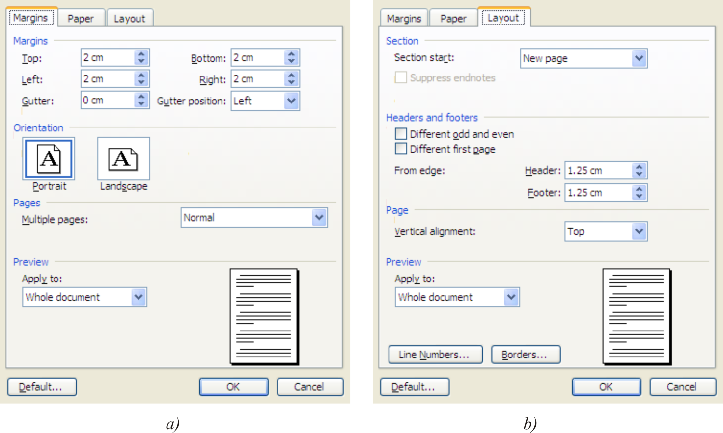
Figure. B.1. Page setup in ECOS: Template for manuscripts: a) Margins; b) Layout.
Table B.1. Word styles in ECOS: Template for manuscripts.
Style | Font | Indent | Line spacing | Paragraph spacing
Title | Arial, 18 pt, Bold, | Left: 1 cm, Right: 1 cm, Centred | Single | Before: 12 pt, After: 24 pt
PS Authors | Arial, 12 pt, Bold, Italic | Left: 1 cm, Right: 1 cm, Centred | Single | Before: 0 pt, After: 0 pt
PS Affiliation | Arial, 10 pt, Italic | Left: 1cm, Right: 1 cm, Centred | Single | Before: 12 pt, After: 0 pt
PS A&K | Arial, 10 pt | Justified | Single | Before: 0 pt, After: 0 pt
PS Heading A&K | Arial, 11 pt, Bold | Left: 0 cm, Left | Single | Before: 12 pt, After: 3 pt
PS Heading 1 | Arial, 14 pt, Bold | Left: 0 cm, Hanging: 0.5 cm, Left | Single | Before: 6 pt, After: 3 pt
PS Heading 2 | Arial, 12 pt, Bold | Left: 0 cm, Hanging: 0.7 cm, Left | Single | Before: 0 pt, After: 3 pt
PS Heading 3 | Arial, 10 pt, Bold | Left: 0 cm, Hanging: 1 cm, Left | Single | Before: 0 pt, After: 3 pt
PS Heading 4 | Arial, 10 pt, Italic | Left: 0 cm, Hanging: 1.25 cm, Left | Single | Before: 0 pt, After: 3 pt
Normal (Body Text) | Arial, 10 pt | Justified | Single | Before: 0 pt, After: 3 pt
PS Footnote text | Arial, 8 pt | Justified | Single | Before: 0 pt, After: 3 pt
PS Equation | Arial, 10 pt | Left, number, Right | Single | Before: 3 pt, After: 4 pt
PS Figure Place | Arial, 10 pt | Centred | Single | Before: 9 pt, After: 3 pt
PS Figure Caption | Arial, 10 pt Italic | Left: 0 cm, Hanging: 1.1 cm♣ | Single | Before: 6 pt, After: 12 pt
PS Table Caption | Arial, 10 pt Italic | Left: 0 cm, Hanging: 1.3 cm | Single | Before: 9 pt, After: 3 pt
PS Table Text | Arial, 10 pt | Left: 0 cm, Left | Single | Before: 0 pt, After: 0 pt
PS Table Footnote | Arial, 8 pt | Left: 0 cm, Left | Single | Before: 0 pt, After: 12 pt
LS Nomenclature | Arial, 10 pt | Left: 0 cm, Hanging: 0.5 cm, Justified | Single | Before: 0 pt, After: 3 pt
LS Reference | Arial, 10 pt | Left: 0 cm, Hanging: 0.7 cm, Justified | Single | Before: 0 pt, After: 3 pt
LS Bullet Level 1 | Arial, 10 pt | Left: 0 cm, Hanging: 0.5 cm, Justified | Single | Before: 0 pt, After: 3 pt
LS Bullet Level 2 | Arial, 10 pt | Left: 0.5 cm, Hanging: 0.53 cm, Just. | Single | Before: 0 pt, After: 3 pt
LS Number List | Arial, 10 pt | Left: 0 cm, Hanging: 0.5 cm, Justified | Single | Before: 0 pt, After: 3 pt
♣Centred if caption stays in one row; style “PS Figure Caption + Centered”
Important note: Authors should resize the objects to cover the white space limited by the margins. In the case of Table B.1 row high is resized.

Layout of the manuscript, see Figure B.1b, is defined as:
- Section: New page,
- Header and Footers: From edge: Header: 1.25 cm, Footer: 1.25 cm;
This format should be applied to Whole document.
Starting page of the manuscript comprises five mandatory sections: Paper title, Author’s (or authors’) name(s), corresponding affiliation(s), Abstract and Keywords. The first three sections are indented by 1 cm from the left and right margins of the page, while the second two sections and the rest of the manuscript do not content any indentations. The other information necessary for proper formatting of manuscripts, without the use of ECOS Template, are presented in Table B.1 and described in the previous part of this document.
Nomenclature
It is strongly recommended to include a separate Nomenclature section. The section starts with the heading Nomenclature (“PS Heading 1” style without number). This section lists in detail all the symbols used in the text and their definitions. The list (“LS Nomenclature” style) should include:
Letter symbol; each symbol used in a paper should have a unique definition. After the symbol hit “tab”.
- Accurate and concise definition of the symbol. Definitions do not require “the” and are followed by comma and one space.
- Units of measure used in the paper. No end punctuation in nomenclature.
All Letter symbols (dimensional and dimensionless) should be listed in alphabetic order. Letter symbols are followed by Greek symbols, subscripts and superscripts. These two sections are under the separate sub headings (“PS Heading 4” style without number).
Example:
- $c$ specific heat, J/(kg K)
- $h$ heat transfer coefficient, W/(m2 K)
- $\dot{m}$ mass flow rate, kg/s
- $t$ temperature, °C
Greek symbols
- $η$ efficiency
- $φ$ maintenance factor
Subscripts and superscripts
- $a$ air
References
Authors should acknowledge the referenced sources (either from a printed document or from the web) whenever they:
- Paraphrase or summarize another person's ideas or points.
- Quote another person's work.
- Use information from any source, including information contained in tables, graphs, figures or diagrams.
ECOS uses the numeric system of referencing, according to the conventions set down in the Vancouver/Numeric style. References to cited literature should be numbered consecutively throughout the paper and collected together in a section References. Heading, References, is “PS Heading 1” style without number, while the list of cited material is “LS Reference” style.
In the text, each reference number (Arabic numerals) should be enclosed in square brackets on the same line as the text ([1], [2]), before any punctuation such as: full stops, commas, colons and semi-colons. Author should refer to the reference number, and do not use “Ref. [3]” or “reference [3]” except at the beginning of a sentence: “Reference [3] was...” When multiple references are cited at a given place in the text, author should:
- Use a hyphen to join the first and last numbers that are inclusive: [2-5].
- Use commas (without space) to separate no inclusive numbers in a multiple citation: [2,3,4,5,7,10] or abbreviated to [2-5,7,10].
A reference to a particular article or chapter in a book may be cited in the text multiple times but must only appear once in the reference list. During the text preparation authors are encouraged to:
- Substitute reference numbers for the name of the author whenever appropriate:
- As Smith, Wesson and Ruger, and Williams et al. demonstrate, incorrect.
- As [1], [2], and [3] demonstrate, correct.
- As Smith [1], Wesson and Ruger [2], Williams et al. (for more than 2 co-authors) [3].correct.
- Place numbers directly after the reference rather than at the end of a clause or sentence, (unless the reference ends at the end of a clause or sentence).
- One study examined the energy efficiency in ... [1], incorrect.
- One study [1] examined the energy efficiency in ...., correct.
Authors must provide a full description of each source which has been cited in the text in a reference list. The information must be sufficient to make it possible for interested readers to easily locate and obtain the source. The references should be listed in the same order as cited in the text, not in alphabetical order.
References to electronic data available only from personal Web sites or commercial, academic, or government ones where there is no commitment to archiving the data, should be avoided. Depending on the circumstances, private communications, Web site addresses, citations like “In preparation” and “To be submitted” may be incorporated into the main text of a paper or may appear in appendix. The following examples demonstrate the format for a variety of types of references.
- Journals:
- Sciacovelli A., Verda V., Entropy generation analysis in a monolithic-type solid oxide fuel cell (SOFC). Energy 2009;34(7):850-65.
- Yapici H., Kayatas N., Albayrak B., Basturk G., Numerical calculation of local entropy generation in a methane air burner. Energy Convers Manage 2005;46:1885-919.
- Books and other monographs:
- Bejan A., Shape and structure, from engineering to nature. Cambridge, UK: Cambridge University Press; 2000.
- Szargut J., Morris D.R., Steward F.R., Exergy analysis of thermal, chemical and metallurgical processes. New York, USA: Hemisphere Publ. Corp; 1988.
- Chapter in a book:
- El-Halwagy M.M., Sustainable pollution prevention through mass integration. In: Sikdar S., Diwekar U., editors. Tools and methods for pollution prevention. Dordrecht, Netherlands: Kluwer Academic Publisher. 1999. p. 233-76.

- Conference Papers:
- Bolliger R., Favrat D., Maréchal F., Advanced power plant design methodology using process integration and multi-objective thermo-economic optimisation. In: Kjelstrup S., Hustad E., Gundersen T., Røsjorde A., Tsatsaronis G., editors. ECOS 2005: Proceedings of the 18th International Conference on Efficiency, Cost, Optimization, Simulation, and Environmental Impact of Energy Systems; 2005 Jun 20-25; Trondheim, Norway. Tapir Academic Press:777-84.
- Scientific or technical report:
- Holland A., O’Sullivan B., Weighted super solutions for constraint programs. Cork, Ireland: University College Cork, Cork Constraint Computation Centre; 2004 Dec. Technical Report No.: UCC-CS-2004-12-02.
- Dissertation:
- Magistri L., Hybrid systems for distributed generation [dissertation]. Genova, Italy: Università di Genova; 2003.
- Web references:
- National Institute of Standards and Technology. NIST-JANAF Thermochemical Tables – Available at:<http://kinetics.nist.gov/ janaf/> [accessed 12.3.2008].
- EUROPA- the official web site of the European Union. Official Journal of the European Communities. Directive of the European parliament 2001/77/ES – Available at: <http://eur-lex.europa.eu/LexUriServ/LexUriServ . do?uri=OJ :L: 2001:283:033: 0040:EN:PDF>.[accessed 17.8.2010].
- Galovic A., Virag Z., Zivic M., Analytical entropy analysis of recuperative heat exchangers. Entropy 2003;5:482-95. doi:10.3390/e5050482. Available at: <http://www.mdpi.com/ 1099-4300/5/5/482/pdf> [accessed 15.6.2010].

Character formatting is also available in the Formatting palette.
In all other cases, including: title, authors, affiliations, abstract, keywords, footnotes, acknowledgments, appendices, nomenclature and references, the ECOS template automatically inserts the correct blank vertical space between lines.
Authors are advised to use Microsoft Equation Editor 3.0 or MathType instead the Microsoft Math Editor built-in Word 2007/10. Users of Word 2007/10 may insert the Microsoft Equation 3.0 object in the text by following operations (Insert | Object | Create New | Microsoft Equation 3.0).
Journal titles can be abbreviated, see URL: http://www.efm.leeds.ac.uk/~mark/ISIabbr/.
If a journal carries continuous pagination throughout a volume the month and issue number may be omitted.

